Summercore Google Drive Challenges
Workshop Version
shortcut tinyurl.com/gdrive33

Google Drive Challenge #1

1A) IMPORTANT Choose MAKE A COPY under the file menu and include your name in the FILE NAME. If working with a partner, choose share and give your partner EDIT privileges.

1B) Partner 1 should choose RESEARCH under the TOOLS menu and find an article about the town where he/she grew up and insert it here:

1C) Partner 2 should choose RESEARCH under the TOOLS menu and find an article about the college where he/she went and insert it here:

1D) Each partner should use the COMMENT feature under INSERT to comment on the writing of the other partner.

1E) Check the detailed Revision History. (Hint: Found under File Menu)

Google Drive Challenge #2

2A) Correct the speling errars in this sentance using mouse clicks.(Hint: control-click or right mouse click on the selected word)

2B) Enter a definition for the word “obstreperous.”
(Hint: Define found under Tools Menu)

2C) The number of words in the document before this item is _____.
(Hint: first you need to select the text, then choose Word Count under the Tools Menu)

2D) Translate this document into the language of your choice.
(Hint: found under the Tools Menu)

Google Drive Challenge #3 (Hint: use the Tool Bar for these challenges)

3A) Apply this formatting to 3C and 3E by using the Paint Format tool on the toolbar.
3B) This means you first highlight the text in 3A.
3C) Then you single click on the Paint Format tool which is to the left of “Normal Text” on the toolbar.
3D) You can now highlight 3C and it changes automagically to the desired format.
3E) If you double click on the Paint Format tool, you can paint repeated instances.
3F) To get out of copy format mode, you triple click on the Paint Format tool.

Google Docs Challenge #4: The Research Feature under Tools
Change the spacing for this challenge to double-space by highlighting first then choosing the Line Spacing Tool next to the Justify option on the toolbar or under the Format menu.

4A) Research Jane Austen by selecting the words “Jane Austen” in this sentence and choose Research from the Tools Menu. Copy and then paste a quotation below from the extended list of quotations.

4B) Insert a photo of Jane Austen. Add an atttribution. Make the photo smaller. Close the research box.

Google Drive Challenge #5: Special Characters from the Insert Menu

5) Duplicate these symbols into the right column by typing the missing characters without choosing Copy and paste.

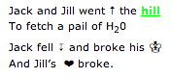 | Jack and Jill went __ the hill  To fetch a pail of H2O  Jack fell __ and broke his __  And Jill’s __ broke.

Google Drive Challenge #6: OutDenting Text Properly
(Hint: use the ruler above this document for these challenges)

7A) Compute how many tab stops and how many returns/enters were pushed.

In this challenge, the typist pressed __ tab stops and pressed the Return/Enter bar __ times.

7B) Next, add one entry to the sample, mimicking the tab structure, for an assignment due 11/7.

due Tuesday 11/1 Read pp 23-45 of Catcher in the Rye and discuss how Holden chooses to upset another member of his family.
due Wednesday 11/2 Read pp 45-56 of Catcher in the Rye and try to explain where the ducks actually go in the winter when they leave Central Park. Is Holden wrong about the ducks, or is he just misguided?
due Friday 11/4 Research JD Salinger’s life between 1960 and 1970 and whether or not any of his homes were the settings for his books.

Google Drive Challenge #7: Insert a photo of you and your partner by adding an image from the Insert Menu and then Take a snapshot.

Bonus: Tables

Create a new document (sample below) that can be used in your curriculum. Create a table that is three columns and two rows -- column 1 is the topic, column 2 is a graphic and column 3 is a link to a web site. To make the document visually appealing, change the background color of the page using the feature under Page Setup.
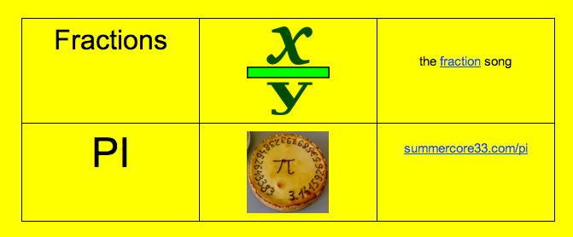

Bonus: Styles and Table of Content

Highlight and then change each of the challenges titles to the Heading 1 format, individually, by going to Format > Paragraph Style > Heading 1 > Apply Heading. Now you can modify the format of one of the headings and you will see all the challenge titles automagically change to be the same after you choose Format > Paragraph Style > Heading 1 > Update Heading 1.
Next, click at the top of the document (right below “Workshop Version”) and add a Table of Contents by going to Insert > Table of contents. Write your name below this challenge and then highlight and change your name to the style Heading 1. Make sure to refresh the Table of Contents by clicking on the circle arrow on the bottom right corner of the table of contents.

