Blank Piece of paper for all Summercore participants to enter
Shortcut? tinyurl.com/kevin32
Only AOS people can access this file.

Things each of you on varsity should add to this document?
1 picture, 1 comment, 1 instance of research, 1 link
•
Alisa
•Invention at Play
http://invention.smithsonian.org/centerpieces/iap/playhouse_main.html
Want to play and/or create? These activities focus on the four types of play to promote learning.
•
•
Amber
•Flat Stanley- USA - Learn the 50 Nifty with Flat Stanley 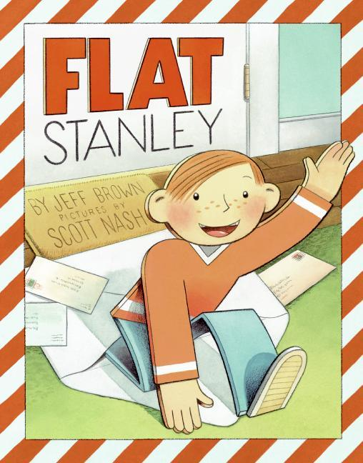
•Learn the 50 States through games
•American Folklore all 50 states- Choose one of the 50 states to read folktales, myths and legends from the 50.

Amy
•Simile - With Phrase Up type in a partial phrase, and this site adds a simile
•Simile - From definition to end-lesson feedback, a variety of hands-on activities
•
Annie
•
•
•
Bess
• This is a great website where students can see various 3D shapes (which are often hard to draw in real life). They can create interactive 3D shapes and view nets of 3D figures which will help with surface area. 3D Shapes
• This website allows you to create graphs using slope and intercept. Students can manipulate the graphs online seeing the effects of coefficients etc. without having to draw all the different graphs. Also comes with an activity page. Slope Intercept Activity
• Fun Algebra game where students solve equations with one variable in order to keep the Nuclear reactor from exploding. Great option for students to have fun extra practice. Nuclear Algebra Game

“Stand firm in your refusal to remain conscious during algebra. In real life, I assure you, there is no such thing as algebra” - Fran Lebowitz

Labradoodle Site

Beth
•The future of ed tech
•Apps to use
•
Bianca

•Voices of Youth--UNICEF Voices of Youth is UNICEF's online home for young people to know more, learn more, and do more about our world.Students can watch videos and practice listening to Spanish language from native speakers around the world

“It is not the language of painters but the language of nature which one should listen to the feeling for the things themselves, for reality, is more important than the feeling for pictures” - Vincent van Gogh

•Language Games: Games to practice new Spanish vocabulary.
•Spanish Proficency Exercises (university of Texas at Austin) Students can listen to different accents by native speakers in different topics, eg: buy a train ticket, talk about your favorite food, talk about yourself
Clare
•Science Museum - what is global climate change; what can be done about it
•Cell games - tutorials, games and quizzes for plant, animal and bacterial cells
DNA games - learn the structure and function of DNA and RNA

•
•
•
Dorcas
Bom Bom Islet, Principe (Bom Bom Island Resort)
• epubbud offers free children’s ebooks, to expand student access.
• Literature Network for searchable classic literature, including poetry.
- Internet Archive Bookserver Distributed lending and lthe internet
Eddie
•TABLEIZER!
•GenerateData
•
“To err is human--and to blame it on a computer is even more so” - Robert Orben
“To err is human--and to blame it on a computer is even more so” - Robert Orben

Elizabeth
•
•
•

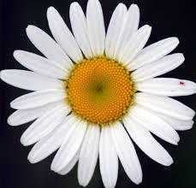Jeri
• Flat Stanley Project
• Civil War
• Animated Shakespeare
Johna
•STATES GAME This would be a fun states game for kids to play when they finish their work early to reinforce their states knowledge.
•NEWS ACROSS YOUR STATE This website can be used to help students research current events that occur in their individual assigned state for States Fair in March
•Multiplication Practice This website would be a great tool for students to use to practice multiplication facts at home or in class if they finish their work early.
Kelley
•Biomes - First Grade (great for first grade animal research project)
  - http://kids.nceas.ucsb.edu/biomes/ (another cool biome website)
•Build a Dinosaur - Second Grade (fun activity for second grade dinosaur unit)
  - Zoom Dinosaurs (another great dino website)
•USA Game - Third Grade (fun state identifying game)
- Countries - Fourth Grade (compare what it is like to grow up in another country vs. growing up in the United States)
Melanie
•
•
•
Natalie
• underground rr site - http://teacher.scholastic.com/activities/bhistory/underground_railroad/ make the underground railroad challenges more real
• animated maps - animated maps show battles of Revolution in an innovative way

•digital newspapers - digital newspapers see history from a primary source

Nita
*Slavery http://www.studysc.org/middle-school/slavery
primary documents about slavery
* cottonhttp://www.trackmyt.com/
from cotton farm through Eli Whitney museum to your T-shirt
*African American religion
http://www.pbs.org/thisfarbyfaith/
Pat
•Google Drive for ipad app - There is a google drive app for the ipad. This seems like it might be an answerto how do we get our stuff off the ipad (whether over to the network, home, etc.)
•Scratch
• couldn’t duplicate bianca in ambers chrome isse in IE
Roxanna
•

•
Sami
• Bohr Model A useful animation that shows the hydrogen model
•Jeopardy Game - Atomic Structure
•videos and de“Science without religion is lame, religion without science is blind” - Albert Einstein
mos“Science without religion is lame, religion without science is blind” - Albert Einstein

"Quote - Stand firm in your refusal to remain conscious during ..." <http://quotationsbook.com/quote/25708/>
"Zoom Dinosaurs - EnchantedLearning.com." 22 Jul. 2013 <http://www.enchantedlearning.com/subjects/dinosaurs/>
"Bom Bom Island Resort | Africa's Eden." 2009. 22 Jul. 2013 <http://www.africas-eden.com/Bom-Bom-Island-Resort.asp>
""Science without Religion Is Lame, Religion without Science Is Blind ..." <http://news.softpedia.com/news/Science-Without-Religion-is-Lame-Religion-Without-Science-is-Blind-85550.shtml>
""Science without Religion Is Lame, Religion without Science Is Blind ..." <http://news.softpedia.com/news/Science-Without-Religion-is-Lame-Religion-Without-Science-is-Blind-85550.shtml>
"Vincent Van Gogh Quotes - Page 2 - BrainyQuote." <http://www.brainyquote.com/quotes/authors/v/vincent_van_gogh_2.html>
"Robert Orben quotes - Thinkexist Quotations." <http://thinkexist.com/quotation/to_err_is_human-and_to_blame_it_on_a_computer_is/223813.html>
"Robert Orben quotes - Thinkexist Quotations." <http://thinkexist.com/quotation/to_err_is_human-and_to_blame_it_on_a_computer_is/223813.html>

